Name Date
Stage 9 End of unit 2 test
1 Work out the value of these expressions.
a 4a − 7b when a = 6 and b = −3
[2]
b 2x2 + 4y³ when x = 4 and y = −2
[2]
c when g = −4 and h = 6
[2]
2 The diagram shows a rectangle.
Write an expression, in its simplest form, for:
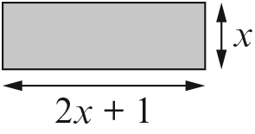
a the perimeter of the rectangle [2]
b the area of the rectangle. [2]
3 Simplify each expression.
a p⁷ × p⁵ = b q8 ÷ q2 = ________________
c = d = [4]
4 Circle the correct answer, A, B, C or D.
a Simplify 4x3 × 3x2 A 12x6 B 12x5 C 7x6 D 7x5
b Simplify 5y × 2y5 A B C D
c Simplify A B C D
d Simplify A B C D
e Simplify A B C D [5]
5 Expand and simplify these expressions.
a (y + 3)(y + 5)
b (m + 1)(m − 2)
c (p − 5)(p − 3)
d (n − 8)²
e (x + 2)(x − 2) [5]
6 Simplify these expressions.
a
b
c
d
e [5]
7 a Use the formula T = px to work out the value of T when p = 15 and x = 2.
[2]
b i Rearrange the formula T = px to make p the subject. [1]
ii Work out the value of p when T = 42 and x = 7.
[2]
8 Make x the subject of each of these formulae. Circle the correct answer, A, B or C.
a A B C
b A B C
c A B C [3]
9 This diagram shows a shape made from a square and a rectangle.
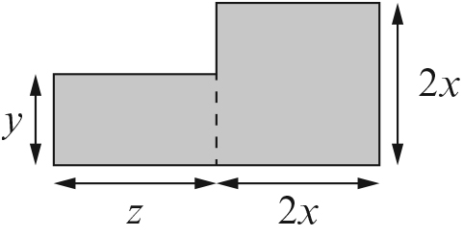
a Write down a formula for the area (A) of the shape.
[2]
b Work out A when x = 3, y = 4 and z = 7.
[2]
c Rearrange your formula to make x the subject.

[2]
d Work out x when A = 79, y = 3 and z = 5.
[2]
[Total: 45 marks]

END OF TEST

